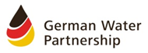
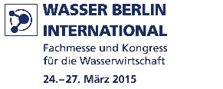
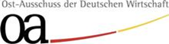

„Water management in South East Europe“
South East Europe Forum in the frame of the WATER BERLIN INTERNATIONAL

26th March 2015, 3.00 p.m. – 5.30 p.m.
Exhibition area, Hall 6.3, room A

Programme
(as of 23/03/2015)

2.30 p.m. | Registration of participants
3.00 p.m. | Welcome  Hubertus Soppert  Member of the board, German Water Partnership e.V.  Executive Director, p2mberlin GmbH
Welcome and moderation
Dr. Martin Hoffmann
Regional Director Eastern Europe, Committee on Eastern European Economic Relations

3.10 p.m. | Introduction  Water Management in South East Europe - Current situation and needs  Miodrag Kolić  Project Manager, Network of associations of local authorities of South East Europe (NALAS)
3.25 p.m. | Wastewater management and energy saving measures in Prizren, South West Kosovo  Dipl.-Ing. Ulrich Goerschel  Director International Consulting, p2mberlin GmbH
3.40 p.m. | Design, build, finance and operate of the wastewater treatment & sewer system for the City of Budva, Montenegro  Joachim Dudey  Director Sales & Financing, WTE Wassertechnik GmbH
3.55 p.m. | Qualification as key for development in South East Europe  Dr. Heike Burghard  Dr. Burghard – ibd

4.10 p.m. | Discussion  Miodrag Kolić, Project Manager, Network of associations of local authorities of South East Europe (NALAS)  Dipl.-Ing. Ulrich Goerschel, Director International Consulting, p2mberlin GmbH  Joachim Dudey, Director Sales & Financing, WTE Wassertechnik GmbH  Dr. Heike Burghard, Dr. Burghard – ibd
5.00 p.m. | Regional cooperation on flood management in the Sava River Basin  Dr. Dejan Komatina  Secretary, International Sava River Basin Commission
5.15 p.m. | Closing
5.20 p.m. | End of the forum

Possibility of participation at the „Berliner Abend“ (reception).
Simultaneous translation English-German will be provided during the South East Europe Forum.

