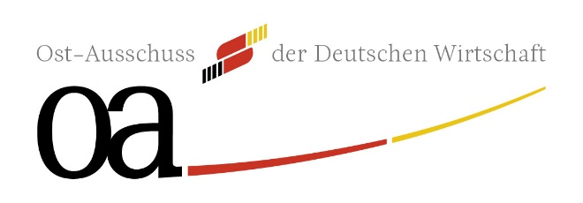

Project information as preparation for the meeting of the
German-Croatian task force
13th November 2025

Please note that this document will be send one on one to the representatives of Croatia
to assure a professional preparation of the meeting.

Please send all information in English not later than 29th September 2025

Please do not add attachments.

Contact: Anja Quiring (a.quiring@oa-ev.de)

Submited via (please indicate)

- Ost-Ausschuss der Deutschen Wirtschaft e.V.

- AHK Kroatien

Title of the project proposal / contact person in the company:

Brief Project Overview:
Has a contact person been named on the Croatian side?

Project progress:
Petita:

Impulses and Strategic Proposals:
(Open field for ideas, strategic areas or suggestions for future cooperation)

